PC Info Readme

See also: [Setup Windows System Readme.docx](https://rethinkit365.sharepoint.com/:w:/s/Apps/EQb7pu3rIAhHpWPd-m8goRUBQlUFZHGSt26slqWjbIHJXg?e=DgA227)

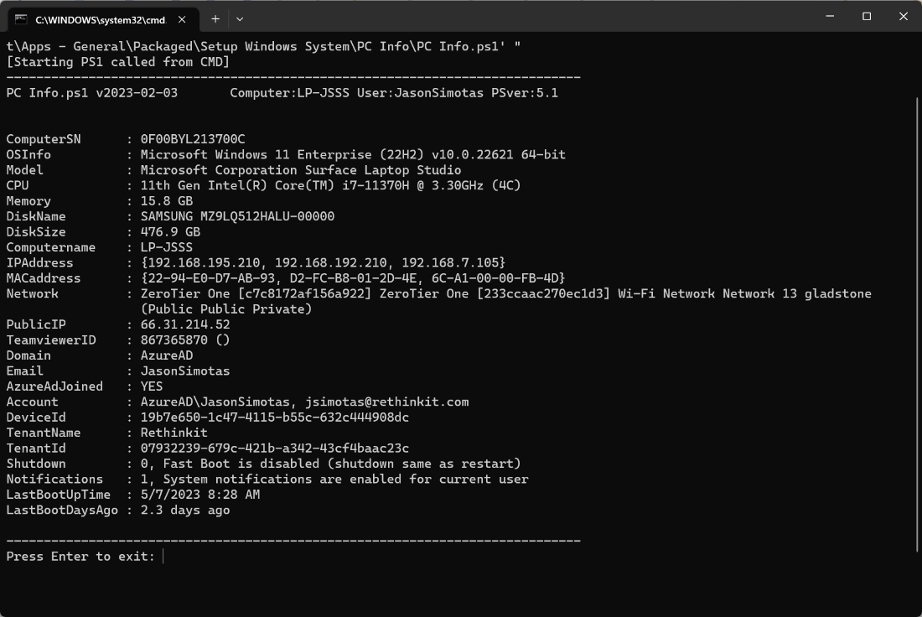

**Overview**

Run as user (not as admin)

Shows all kinds of useful information about the PC and User

**To Run**

*Press Windows-R (Run) and paste*

powershell -executionpolicy bypass Invoke-Expression (Invoke-WebRequest https://raw.githubusercontent.com/RethinkitSupport/pcinfo/main/PC%20Info.ps1 -UseBasicParsing).Content

*Open Powershell and paste*

Invoke-Expression ((Invoke-WebRequest https://raw.githubusercontent.com/RethinkitSupport/pcinfo/main/PC%20Info.ps1 -UseBasicParsing).Content)

*Download Ps1 and run*

Download from here: [PC Info.ps1](https://github.com/RethinkitSupport/pcinfo/blob/main/PC%20Info.ps1)

**Information Returned**

*Fast Boot*

Most IT pros think this should be 0 Off. Windows is 1 On by default.

If Fast Boot is on for a computer, it means that shut down is the same as hibernation. In this case a shut down is not as good as a restart for applying updates etc.

Turn this off to go back to a slower but safer shutdown. The speed benefit is negligible anyway if an SSD is installed.

Note: The *Setup Windows System* package turns off Fast Boot

|  |
| --- |
| To turn off fast startup (hiberbootenabled) manually  Note: This is a system setting and will require admin access to change.  Press Win+R > "control" > "power buttons" > Turn on fast startup [Untick this box] |

*Notifications*

Most IT pros think this should be 1.

If this is 0, it means that the user has opted out from all system notifications, regardless of source.

**To Update the Tool**

Edit *PC Info.ps1* as needed.

Open *Github* as Rethinkit support

Open *PC Info* repository and *Add file > Upload file* and drop the updated file > *Commit Changes*

<https://github.com/RethinkitSupport/pcinfo/upload/main>